ASSIGMENT-2

Build a python code.Assume you get temperature and humidity values and write a condition to continuously detect alarm in case of high temperature

|  |  |
| --- | --- |
| Assignment Date | 8th October 2022 |
| Student Name | Nirsitha R |
| Student Roll Number | 737819ITR055 |
| Maximum Marks | 2 Marks |

while(1):

import random

temperature=random.randint(0,100)

humidity=random.randint(0,100)

print("Temperature:",temperature)

print("Humidity:",humidity)

if((temperature>30)and(humidity>60)) :

print (“Temperature and humidity is high”)

print("Alarm ON!!!")

else:

print("Range is normal")

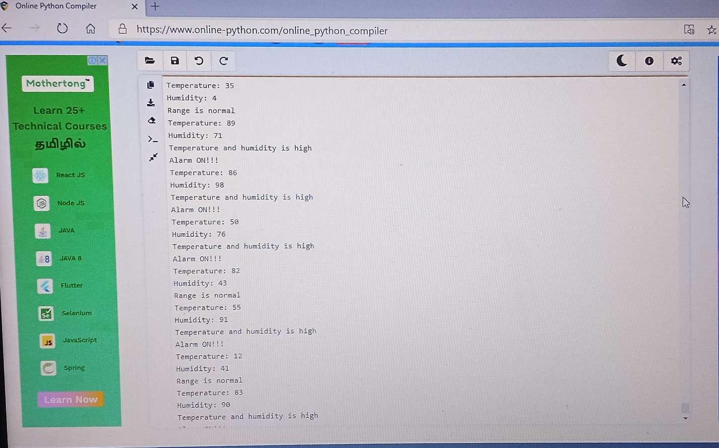OUTPUT: